Lesson 6: Toolchain (Assignment 6)

SourceCode - hello_c

Output - file hello (rpi -64 bit)

Command - wget <https://buildroot.org/downloads/buildroot-2023.02.7.tar.gz>

Command - tar tf buildroot-2023.02.7.tar.gz | head

Command - tar xf buildroot-2023.02.7.tar.gz

Command - ls buildroot-2023.02.7

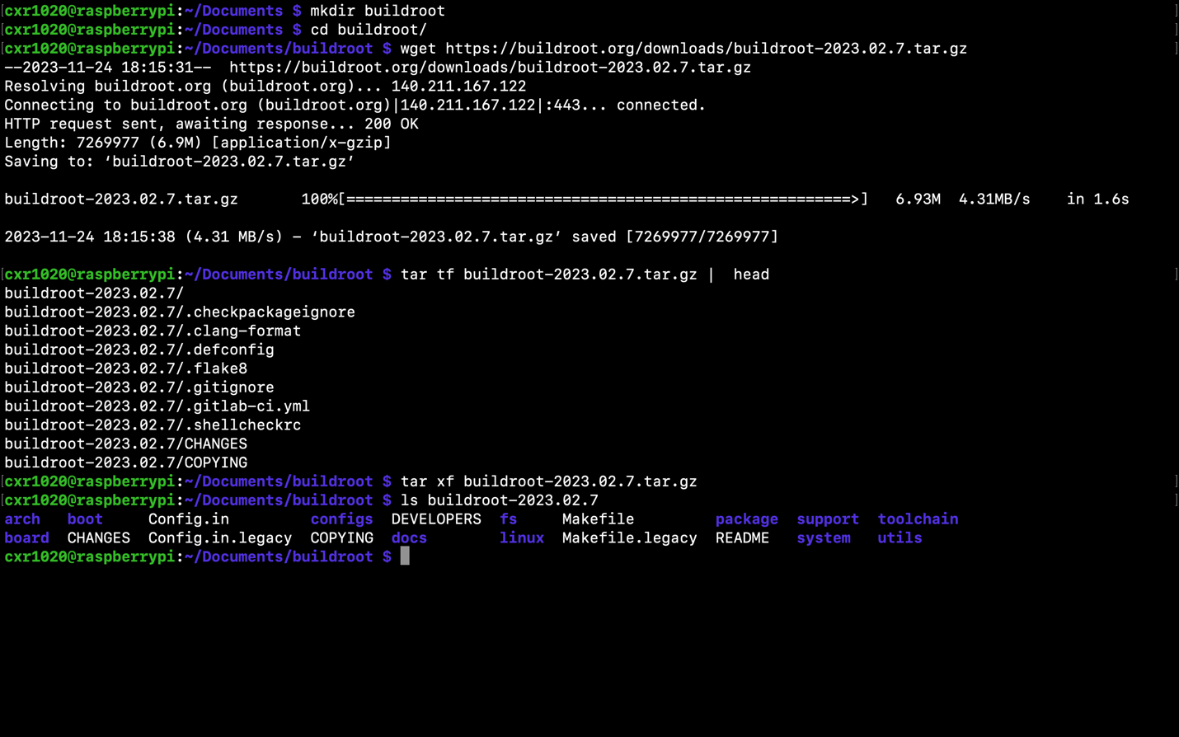

Output – README

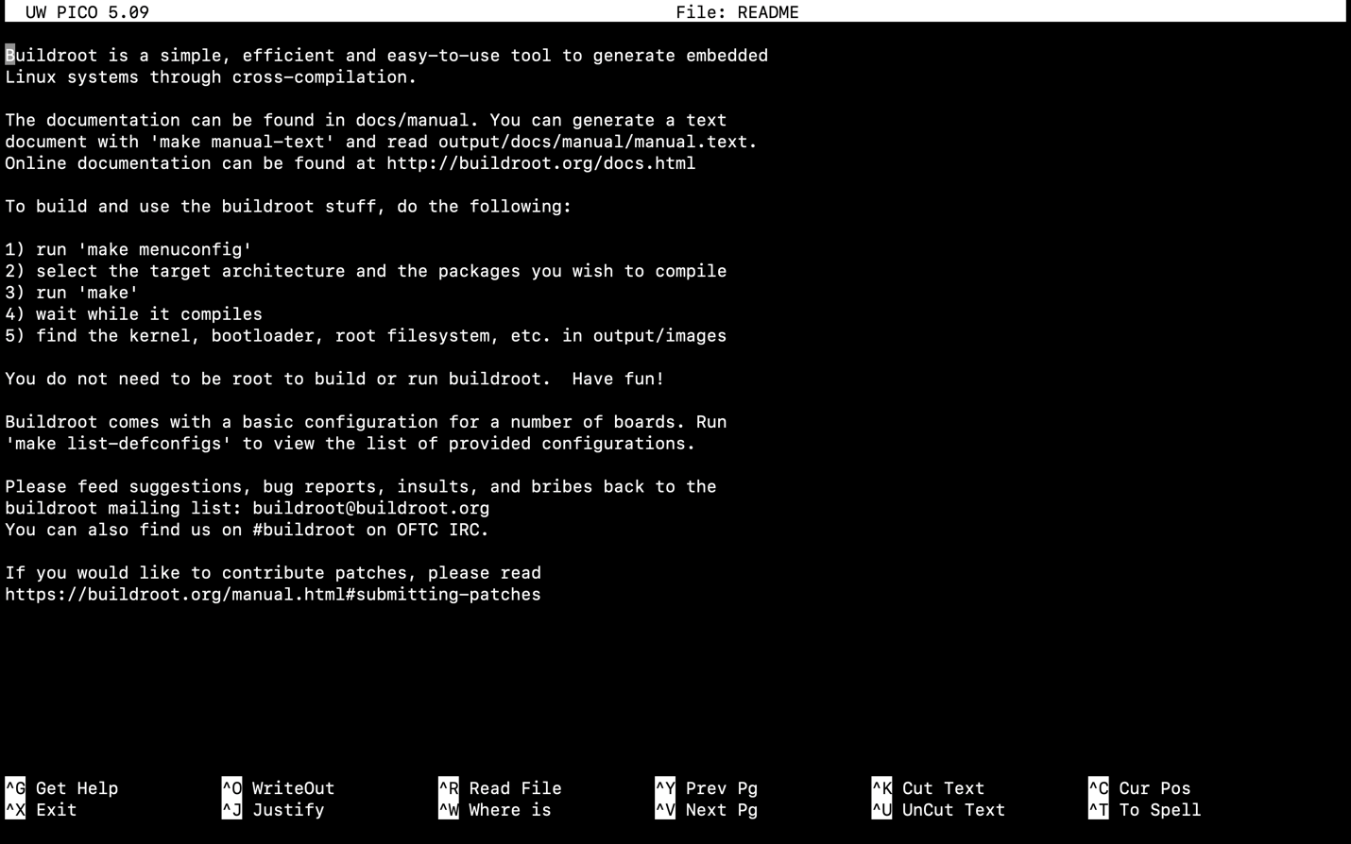

Command. - sudo apt-cache search libncurses

Command - sudo apt install libncurses-dev

Command - make menuconfig (success)

Command - ls configs/

Command - make raspberrypi4_defconfig

Output - make menuconfig

Output - make menuconfig (toolchain)

Output - make menuconfig (C library)

Output - make menuconfig (System Configuration) (notice that init system would be busybox instead of systemd)

